**An Analysis of Within-Group Correlations Between Specialization and Fluctuation**

Referee one posted the following comment/question (I’ve highlighted the question of interest for the following analysis):

***(1.7)*** *\*\* I would like to better understand the statement that increases in DOL and specialization with group size were associated with increases in fitness. What did not come across clearly is to what extent this is causal, and whether there might be other effects of large group size on colony fitness, beyond or in addition to DOL and specialization. For example, there is substantial variation in growth rate and time to eclosion _within_ colonies of the same size, as well as across colonies of different sizes. Is this variation consistent with the explanation of DOL and specialization? I.e. do colonies of a given size which happen to have lower levels of DOL/specialization also fall on the lower end of growth rate for colonies of that size?*

Seeking insight from the model, I used our “best fit” model that we use throughout the rest of the paper (i.e., $σ=0.1, η=7$ in Fig. 3A and 3B). I compared rank correlation (specialization) against fluctuations in both stimulus and task performance across two different time windows: 200 time steps and 1 time step. Remembering that 200 time steps was the time span we used to calculate our specialization metric, this longer time window is analogous to one day in the experimental set up. The shorter 1 time step window represents a much shorter time frame.

**Longer time frame: Fluctuations over 200 time step windows**

Plotting specialization on the x-axis and stimulus fluctuations on the y axis, we see that fluctuations generally decrease with group size.

However, when we break out the results by group size and normalize within group (note that the axes for each group size panel are different), we find no correlation between specialization and task stimulus.

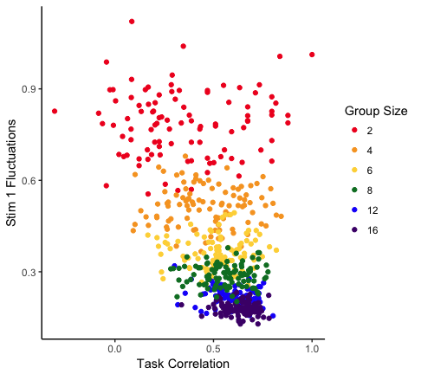

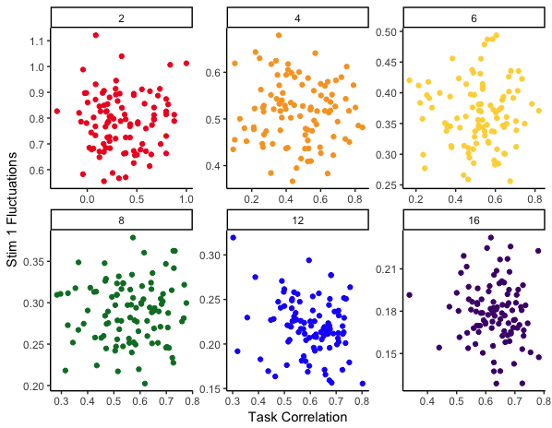

The same trend holds for fluctuations in task performance at the colony level: no correlation within group size.

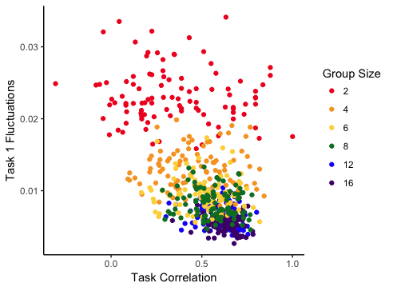

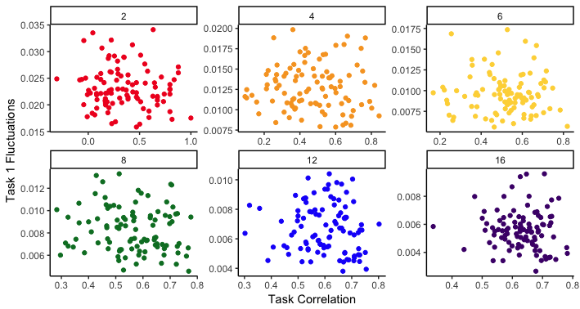

**Shorter time frame: Fluctuations over 1 time step windows**

At shorter time frames, we actually do find a correlation between specialization and stimulus fluctuations within group size.

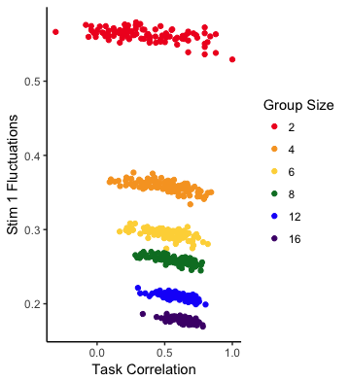

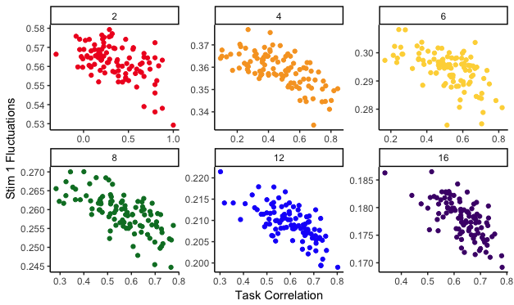

According to the tests I ran, there are significant correlations between task performance fluctuations and specialization in group sizes 12 and 16 only.

